**Module 5 Project Report**

**Application Theme:**

The application I designed for this project is a fitness app prototype aimed at helping users maintain a healthy and active lifestyle from the comfort of their homes. The app is interactive and was created using Figma. The app’s theme is simple and user-friendly, featuring four main sections: Home Page, Explore, Analytics, and Profile. The onboarding page allows users to either create an account or log in, offering a seamless entry into the app. On the home page, users can find popular workouts and a daily plan based on their fitness level. Selecting one of the popular workouts redirects users to a detailed workout page. The Explore section displays recommended workouts, challenges, and warm-up options, while the Analytics section allows users to track key health metrics, including calories burned, cycling/running stats, heart rate, step count, and water intake. The Profile section provides a space for users to manage their personal information and track their progress.

The app’s overall design is minimalist, focusing on essential features with a clean layout and intuitive navigation. The four buttons at the bottom of the screen (Home, Explore, Analytics, Profile) provide easy access to different sections of the app.

Purpose of the Application:

The primary purpose of this *Fitness* app is to offer users the ability to exercise and track their fitness goals from home without the need for a physical instructor. By providing easy access to popular workouts, daily fitness plans, and detailed analytics, the app is designed to motivate users to stay active and maintain a healthy lifestyle. The app's design prioritizes simplicity, with clear icons and minimal colour contrast to ensure accessibility for all users. Bold, black text and clear icons improve readability, making navigation effortless. The app is built to be accessible to people of various fitness levels, offering personalized workout suggestions and progress tracking to help users achieve their fitness goals.

**Research Findings:**

Based on my research findings and exploring different fitness apps, I found several common UI/UX design similarities across them:

1. Minimalist Design: Most fitness apps use a clean and minimalist design. They focus on functionality with minimal distractions, using a lot of white space to keep the user focused on key elements like buttons and workout stats.
2. Simple Navigation: Navigation is often streamlined to provide quick access to important features. Common elements include a bottom navigation bar with icons for sections like the home page, workouts, progress, and profile, making it easy to switch between them.
3. Personalization Options: Fitness apps tend to offer personalized content, such as customized workout plans or diet recommendations, often based on user preferences or data input during the onboarding process.
4. Clear Calls to Action (CTAs): Buttons and icons are designed to stand out with clear labels (e.g., “Start Workout”, “View Progress”), encouraging users to take action quickly and easily.
5. Large, Readable Fonts: Text is kept large and legible to ensure accessibility, particularly for older users or those with visual impairments. Consistent typography helps establish hierarchy and readability.
6. Colour Contrast and Accessibility: Many fitness apps prioritize high contrast between text and background colours to ensure readability, especially in different lighting conditions (e.g., dark mode options).
7. Interactive Elements: Buttons and links are interactive with hover or press effects that provide feedback to users, indicating that the action has been registered.
8. Progress Tracking: Most apps prominently display progress metrics such as calories burned, step count, heart rate, or workout duration in visually appealing charts or graphs.
9. User Engagement: Many apps use gamification elements, such as badges or rewards, to keep users motivated and engaged in their fitness journey.
10. Mobile-First Design: Most fitness apps are designed primarily for mobile devices, ensuring that interfaces are responsive and touch-friendly, with larger buttons and icons for easy navigation.

These design trends help create a user-friendly experience, ensuring that users can quickly access and interact with key features while maintaining an aesthetically pleasing interface.

**Feature List:**

For creating wireframes and prototypes, I utilized several tools in Figma:

* Frames: I created five pages for the app using the Frame tool. Each page was designed to fit mobile screen sizes, ensuring the app would be optimized for smartphones.
* Buttons: Buttons are used for navigation between pages. I created navigation buttons for Home, Explore, Analytics, and Profile using Figma’s rectangle feature, with clear labels indicating their purpose.
* Home Button: This button, located in the bottom corner of all pages except the home page, allows users to navigate back to the main page at any time.
* Previous Page Button: This button lets users return to the previous page, creating a seamless and intuitive flow between screens.
* Images: I added images to the design to make the app more engaging. I used the “fill” and “fit” options in Figma to ensure images were properly integrated into the layout.

**Obtaining Feedback:**

I asked ChatGPT for feedback on my prototype, and this was the response:

The design has several strengths, including a visually appealing UI with high-quality images, clear call-to-action buttons, and well-organized sections for easy navigation. The data representation on the Flow 1 screen effectively tracks workouts.

However, improvements are needed in a few areas. The login page has contrast issues with text fields blending into the background, and social media login icons should be slightly larger. Adding a progress indicator in the onboarding process and more whitespace in the Explore section would improve usability. Additionally, a colour toggle for light and dark modes, larger play buttons, and filter options for workouts are recommended.

For accessibility, ensuring text readability (16px minimum), enlarging buttons to 44px for mobile use, and testing dark mode contrast are important.

**Wireframe:**

Wireframing was a crucial step in outlining the app’s structure. The wireframe for the app includes eight frames, each representing a different screen within the app. The wireframe focuses on the layout, button placement, and general navigation flow, ensuring that the app’s interface is organized and user-friendly.

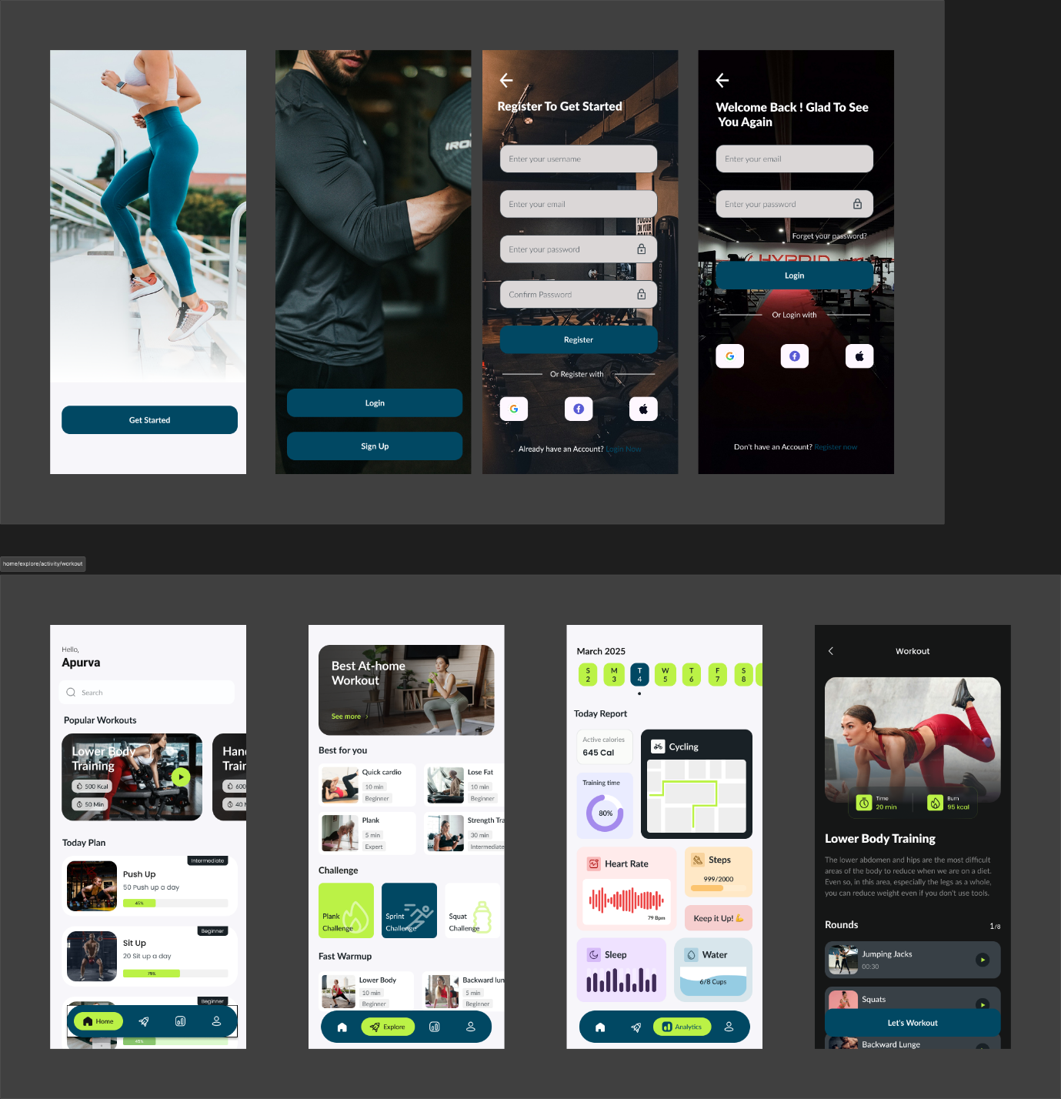

**Interactive Prototype:**

The prototype is a functional representation of the final app, allowing for the testing and evaluation of the design. Using Figma’s interactive features, I created a prototype that simulates real app navigation, giving users a feel for how the app will work once developed. The prototype helped to visualize the user journey and identify any areas for improvement before development begins.

[prototype link](https://www.figma.com/proto/tSvjzmQYnaFUALpsWsjPWP/Fitness-App-Design-UI-KIT-(Community)-(Copy)?node-id=4006-564&t=X13OSQxImWax9vet-1)

